**Name – Ravi Kumar**

**Roll no – 244CA041**

**Assignment 5**

1. **Create the following tables with the following attributes and constraints on them.**

a. Bank (bk_code, bk_name, bk_address)

b. Branch (br_id, br_name, br_address, bk_code)

c. Customer (cust_ID, cust_name, phone_no, address)

d. Account (acc_no, acc_type, balance, br_id)

e. Customer_Account (cust_ID, acc_no)

f. Loan (loan_ID, loan_type, amount, br_id)

g. Customer_Loan (cust_ID, loan_ID)

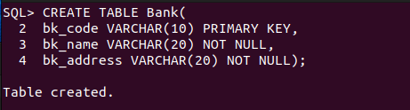

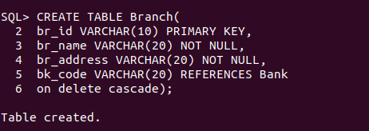



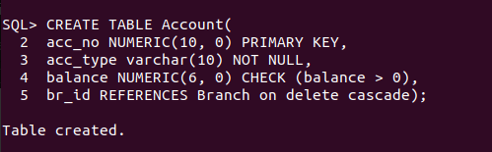

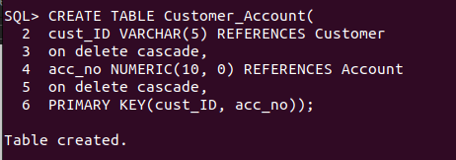

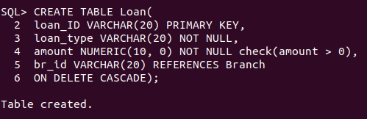

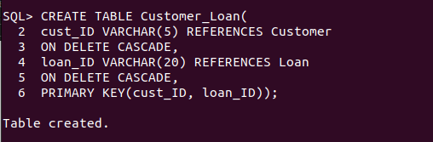

1. **Insert at least five records in each table.**

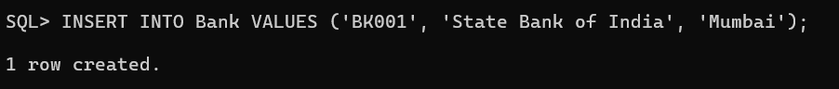

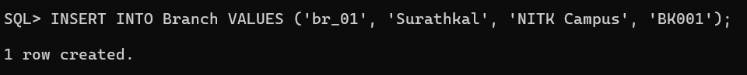



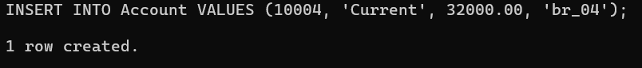

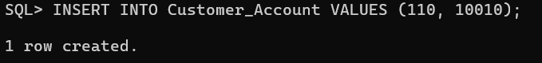

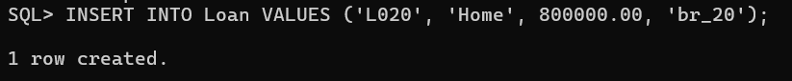

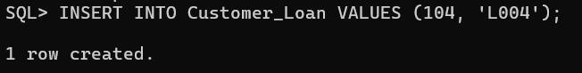

1. **List the details of all customers.**

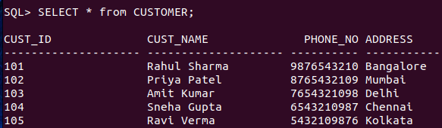

**4. Find the cust_ID and phone number of customer ‘Ravi’.**

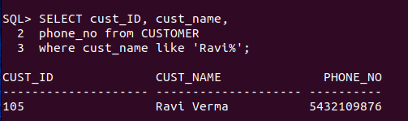

**5. Find the Address of all branches of br_01.**

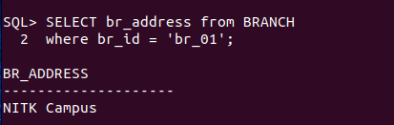

**6. Find the details of Customer having ID 103.**

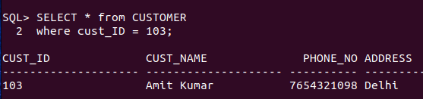

**7. List the account details having balance more than 10000.**

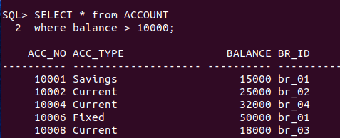

**8. List the account details of branch br_02.**

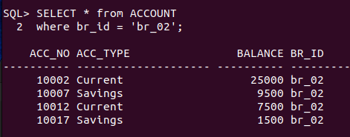

**9. List the loan details of branch br_01.**

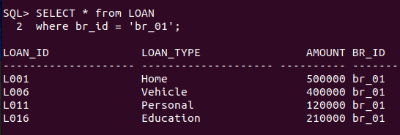

**10. List the account details with their branch address.**

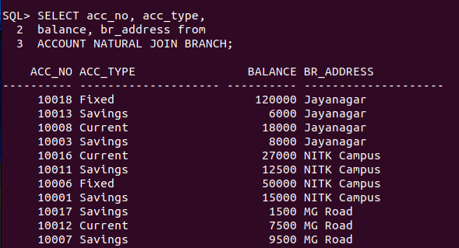

**11. List the customer details with their account details.**



**12. List the customer details having account type ‘Savings’.**

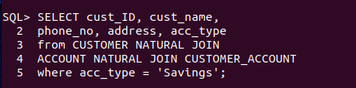

**13. List the customer details having vehicle loan.**

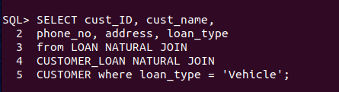

**14. List the branch names of all accounts.**

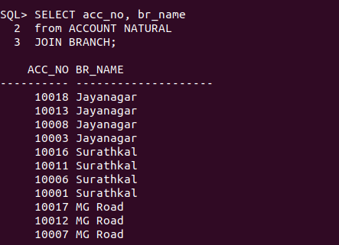

**15. List the customer details going to ‘Surathkal’ branch.**

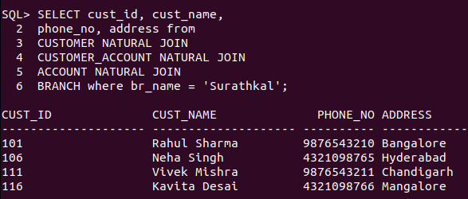

**16. List the customers having loan account in ‘MG Road’ branch.**

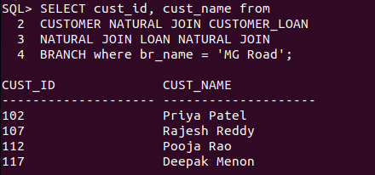

**17. Find the customers having balance between 1000 to 10000.**

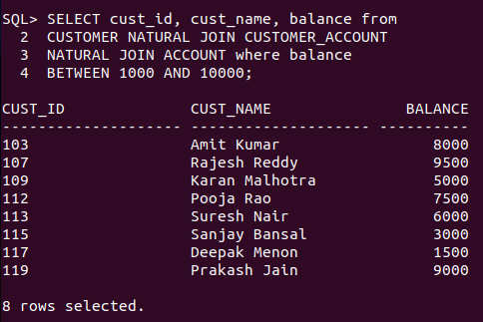

**18. Give a bonus of rupees 100 to customers having more than 10000 balance.**

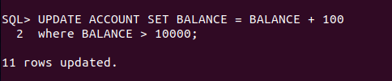

**19. Deduct 50 rupees from customers having less than 500 rupees in balance.**

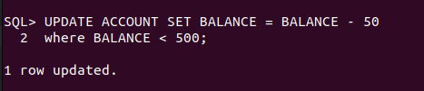

**20. Give the customer details having home loan.**

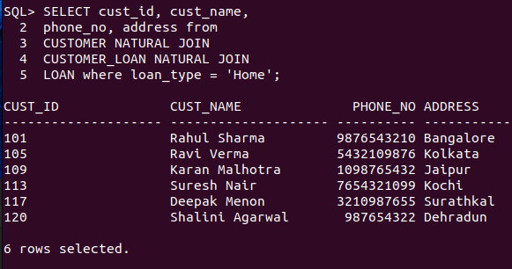

**21. Give the customer details having home loan in ‘NITK’ branch.**

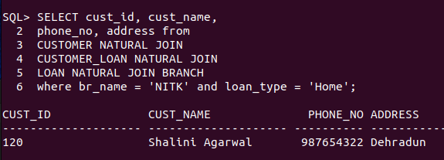

**22. Add a column NOMINEE to the customer table with data type varchar (50).**



**23. List all the account numbers in ascending order of their balance.**

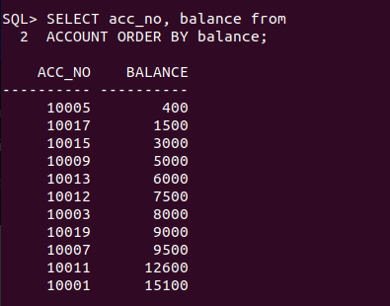

**24. Count the number of customers having account type savings.**

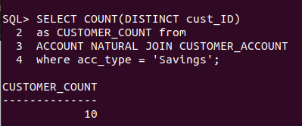

**25. Count the number of customers for each account type.**

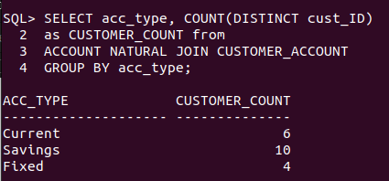

**26. Find the total balance in Savings account.**

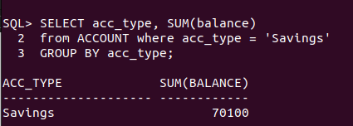

**27. Find the average balance of Current account.**

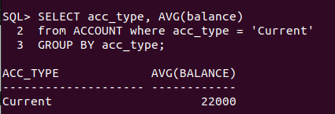

**28. Find the average balance for each account type.**

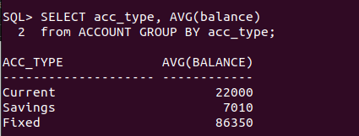

**29. Find the customer details having maximum balance.**

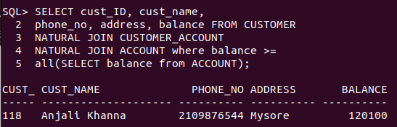

**30. Find the average amount for vehicle loan.**

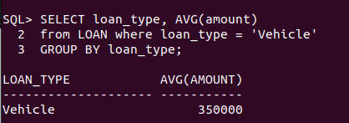

**31. Find the average balance in each branch.**

